H.T No
Regulations:
A15


Sreenidhi Institute of Science and Technology
(An Autonomous Institution)
Code No: 5K703 Date: 18-Dec-2019 (AN)

B.Tech IV-Year I-Semester External Examination, December - 2019 (Regular)
ESTIMATION AND VALUATION (CIVIL)

Time: 3 Hours Max.Marks:75

Note: a) No additional answer sheets will be provided.
b) All sub-parts of a question must be answered at one place only, otherwise it will not be valued.
c) Missing data can be assumed suitably.

Part - A Max.Marks:25

Answer all QUESTIONS.

1. | What are the difference between plinth area method and unit base method? | [3M]
2. | Define lead and lift. | [3M]
3. | Define Task work. | [3M]
4. | Write about bar bending schedule. | [3M]
5. | Write short note on lump-sum contract. | [3M]
6. | Explain the different types of outgoings. | [2M]
7. | Calculate the quantity of earthwork for 90 meter length for a portion of a road in a uniform ground the heights of banks at the two ends being 2.40 m and 1.80 m. The formation width is 8 meters and side slopes 2:1 (H: V). Assume that there is no transverse slope. | [2M]
8. | Enumerate the Labor (Mazdoor) required for Earthwork per 28.30cu.m (1000cu.ft) as per national building organization. | [2M]
9. | What is Obsolescence? | [2M]
10. | What is contract and write about contractor? | [2M]
Part – B Max.Marks:50
ANSWER ANY FIVE QUESTIONS. EACH QUESTION CARRIES 10 MARKS.

11. | a) | Calculate the quantity of cement concrete (1:1.5:3) required for R.C.C lintels over doors and windows of a residental building. There are 6 doors of size 1.2x2.10 and 8 windows of size 1.10x1.80m. Thickness of wall is 230mm and thickness of lintel is 100mm and a bearing on either side of doors and windows is 150mm. | [5M]
 | b) | The plan represents the plan of superstructure wall of a single room building of 5 m x 4 m, and Sections represents the cross-sections of the walls with foundation shown in fig. Estimate the quantities of following items by using center-line method (i) Earthwork in excavation in foundation, (ii) Concrete in foundation, (iii) Brickwork in foundation, and (iv) Brickwork in superstructure.  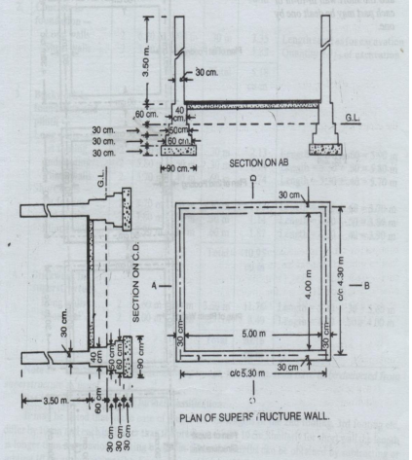 | [5M]
12. | a) | Reduced (R.L) of a ground along the center line of a proposed road from chainage 10 to chainage 20 are given below . The formation level at the 10th chainage is 107 & the road is in downward gradient of 1 in 150 upto the chainage 14 & then the gradient change to 1 in 100 downward. Formation width of road is 10m & side slopes of banking all 2:1 (H:V). Length of chain is 30m  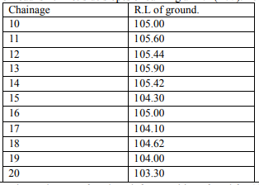 | [5M]
 | b) | Calculate the quantity of earthwork by three method for 200m length for a position of road in an uniform ground the heights of bank at the two end being 1.00m&1.60m . The formation width is 10m and side slope 2:1(H:V) .Assume  that there is no transverse slope. | [5M]
13. | a) | Prepare rate analysis for brick work of 1:6 CM. unit-1 cum. | [5M]
 | b) | Prepare rate analysis for Cement concrete of 1:2:4 unit-1cum. | [5M]
14. | a) | Fig Shows the section along the shorter span of a room of size (4x5.5)m internal dimension. The thickness of the slab is 13cm. The thickness of walls is 40cm.Prepare bar bending schedule.  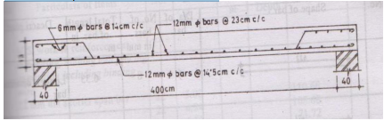 | [5M]
 | b) | What are the advantages of bar bending schedule? | [5M]
15. | a) | Explain schedule contract and its advantages and disadvantages. | [5M]
 | b) | Write short notes on conditions of contract. | [5M]
16. | a) | What are the general specifications of a first class building? | [5M]
 | b) | Distinguish between Sinking fund and depreciation. | [5M]
17. | a) | List and explain any three approximate methods of estimating for building. | [3M]
 | b) | State the methods of calculating quantity of earth work. | [4M]
 | c) | Calculate the number of workers required for 2.83 Cum of cement concrete | [3M]
18. | a) | Derive the expression for 45 degree cranked or bent up bars. | [4M]
 | b) | Explain contract documents in detail. | [3M]
 | c) | A bulking costing Rs 7, 00,000 has been constructed on a freehold land measuring 100sqm recently in a big city. Prevailing rate of land in the neighborhood is Rs150 per sqm. Determine the net rent of the property, if the expenditure on an outgoing including sinking fund is Rs24,000 per annum.Workout also the gross rent of the property per month.Assume net return on building @ 6% and on land @ 4%. | [3M]

-- 00 -- 00 –

